Programs:
LIDIA, PHASER, ACEDRG, REFMAC, RDKIT, COOT

Scenario
(Accurately) informed that there is “a lot of rubbish” among the structure ligand complexes in the PDB, you decide to re-solve the structure of everyone’s favourite PPI drug target MDM2 in complex with the game-changing tool compound Nutlin 3A.

There is a dodgy 1.6 Å structure (PDB: 4hg7) deposited by a disreputable group….so you plan to use their deposited reflections, but start from someone else’s molecular replacement model

There is a nice MDM2 structure from another group that you choose for your startpoint (4qo4). You plan to use modern tools to make a start model for Nutlin 3A. The search model is from a longer construct and you will only use residues 20-107 of Chain A in the Molecular Replacement.

Task 1: Molecular replacement – Molrep or Phaser
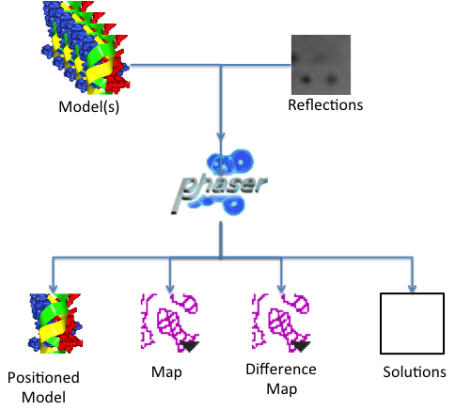
HINT: You can import files (reflections or coordinates) from the PDB directly: in the file browser dialog (accessed by clicking 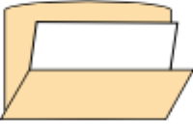): a line at the top allows you to provide the accession code.
HINT: Several tasks (e.g. Phaser molecular replacement) allow you to use a “selection” or subset from the coordinates you provide. For molecular replacement, it may be worthwhile specifying to use only one chain of a model you download: they often contain more than one chain. The syntax for specifying subsets is well worth knowing, but to specify chain A, you need only provide the selection string “A/20-107” (quotation marks should not be included).
HINT: It is best to provide the Free-R reflections so that they are excluded from all phases of the structure determination. In CCP4i2, this (currently) requires you to browse the file system twice: once to locate the reflections, and once to locate the Free-R flags, even though they are in the same file .

SOMETHING GOES WRONG WHEN YOU TRY TO RUN THE PHASER MR TASK

CCP4i2 carefully checks that there are free-R-flags for all reflections in a dataset…the group submitting the structure had not been so careful and your task has exited with an error. For this reason you now have to …

Task 1a: Complete the Free R set provided with the data from the PDB

HINT: The free R-flag completion task is in the “X-ray data reduction and analysis” folder of the Task menu. You are advised to provide the original Free R set for completion to maintain their independent status.

Task 1b: Clone and repeat the molecular replacement
HINT: Clone the original job (select and then click clone button, or use the right mouse button), and change the Free R input to use the (new) complete set.

Questions:
What were the rotation function and translation function scores in the molecular replacement ?
What were the start and finish R-factors in the REFMAC cycles

Task 2: Make your ligand – Make ligand task (LIDIA, ACEDRG, RDKIT)

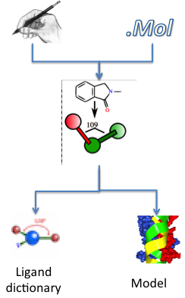

HINT: The structural formula of Nutlin 3A is:
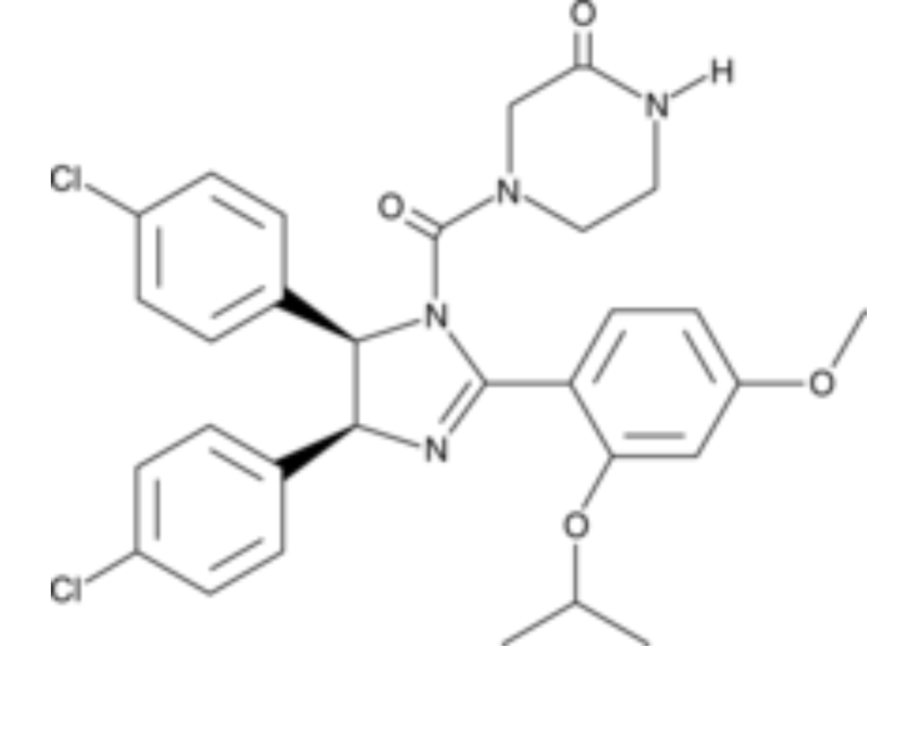
HINT: Lidia (currently) requires you to click both “Apply” and “Quit” to fire up the coordinate generating stuff

Task 3: Introduce your ligand into the structure (Manual model building: COOT)

N.B. You could equally bring a SMILES string or make a sketch in Coot for defining ligand geometry. Depending on local configuration, this latter approach will use either pyrogen (Paul Emsley’s tool) or cprodrg (from Daan van Alten) to generate the dictionary and startng configuration.

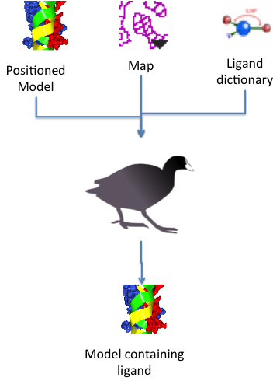
HINT: Since this job will mostly use data objects created by the PHASER job, the easiest way to launch Coot for it is to select the PHASER job, and click the “Manual model building” button at the bottom of the COOT report

This is mostly “COOTery” (and therefore well documented), but a couple of points to note. 1) When you run the “Manual rebuilding task”, you will want to use map coefficients from the molecular replacement task, positioned coordinates from the molecular replacement task, and a ligand dictionary from the “Make ligand” task. Recommended workflow in Coot goes something like

- Find the large blob of difference electron density
- Summon coordinates for the ligand (Coot: “File”->”Get monomer…” and provide the three letter code you gave to the drug)
- Invite Coot to place the ligand into the electron density (“Calculate”->”Other modelling tools”->”Find Ligands…”)

HINT: You will have to delete (or rebuild) Tyr67 and His73 to liberate the space that the ligand will occupy

- Merge the positioned ligand into your main coordinates (“Calculate”->”Merge Molecules…”
- Write updated coordinates into your ccp4i2 session (“File”->”Save to ccp4i2” or “CCP4i2 extensions”->”Save to ccp4i2”)

